**Egypt trip**

**7 days**



**Cairo – Hurghada- Luxor**

**Day 1**

Arrive Cairo then drive to hotel. overnight in Cairo

**Day 2**

Breakfast then drive to visit the museum, citadel and old Cairo churches and mosques and old markets then drive to hotel

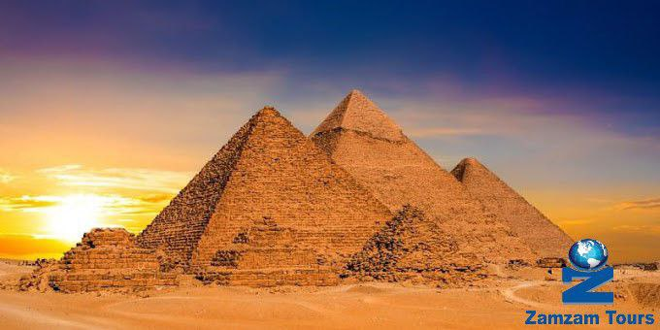

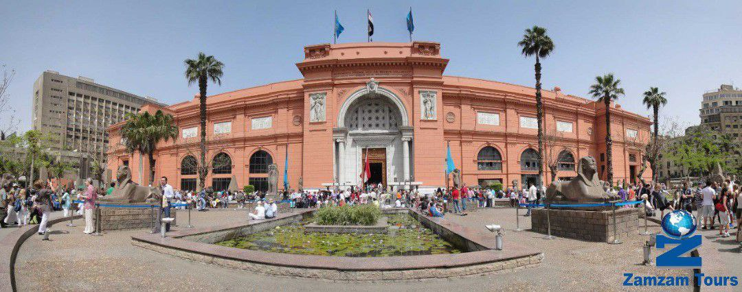

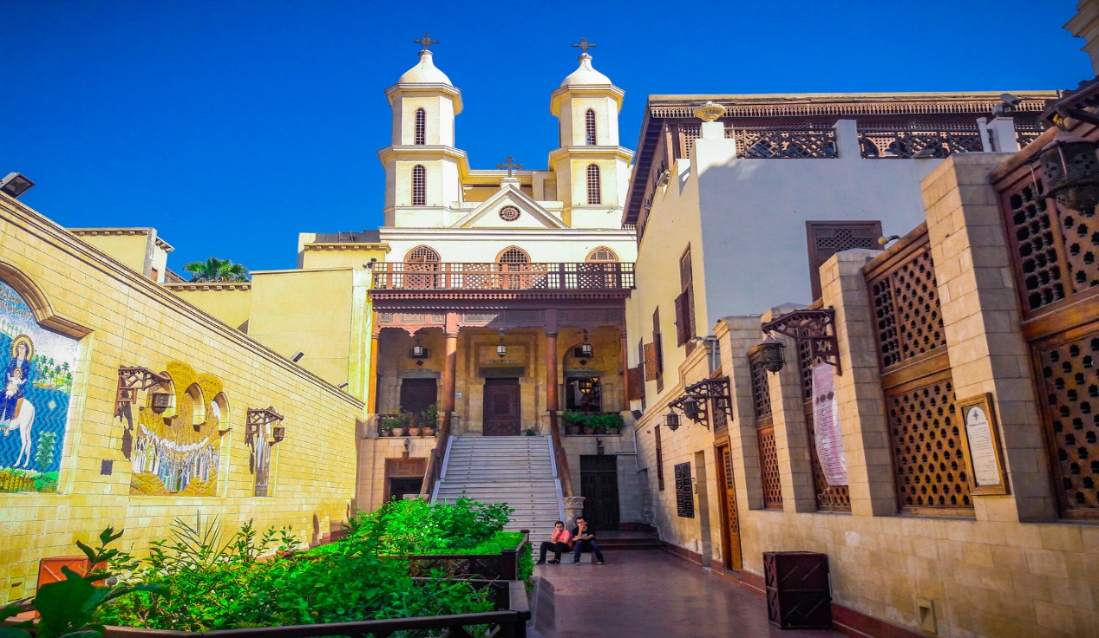

**Day 3**

Visit pyramids, sphinx old Sakkara, Memphis city and enjoy the dessert in Cairo have lunch and drive to hurghada city in red sea have dinner and overnight in hurghada .



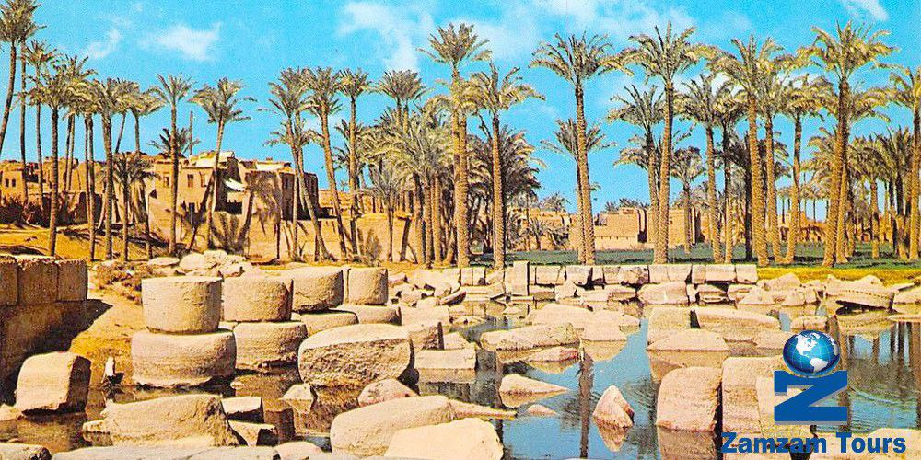

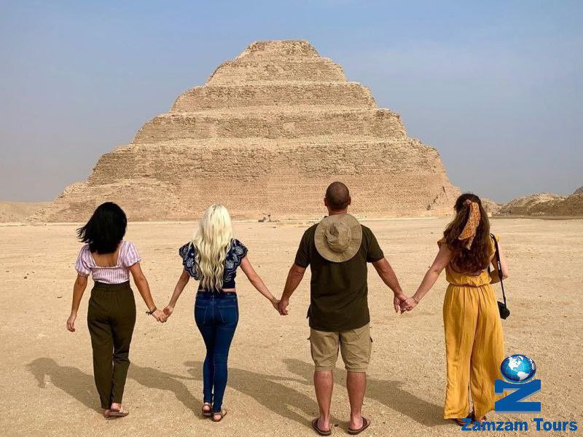

**Day 4**

Breakfast and enjoy the sun on beach and snorkeling diving and activates on the 5 stars resort in hurghada have

Lunch and have city trip in red sea visit old market and coffee shops and old city

Have dinner and overnight at hurghada city.

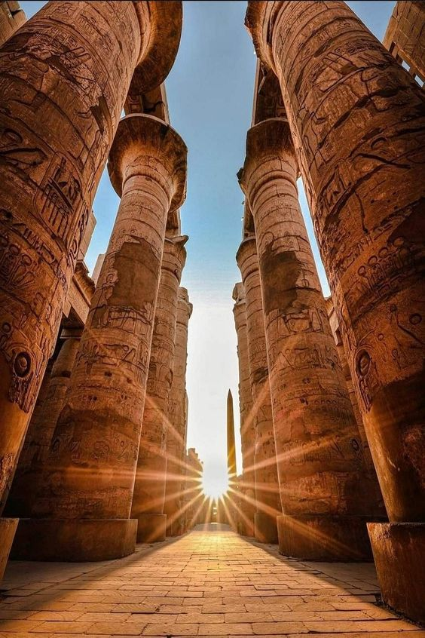

**Day 5**

Early breakfast and drive to the most famous and beautiful city in Egypt and names city of sun and city of kings and queens its ( Luxor city ) arrive visit Luxor temple and Karnack temple and have lunch and have rest on hotel on Luxor and about 8 pm have trip in Luxor city and enjoy civilization on Nile river on Luxor and have drinks on river side and enjoy Luxor songs and dancing in party for our group gift for our clients by our company and our staff

Dinner and overnight in Luxor.

**Day 6**

**early breakfast and have the bus to the balloon station for trip over Luxor city to see all temple and tamps and the west bank and oldest temple in Egypt and back for lunch and start visit ( hut sheb soot and west bank and the kings and queens valley ) day 6 all visits is optional paid by clients**

**and drive back to hurghada**

**have lunch and overnight on red sea in hurghada**

Overnight at hurghada.

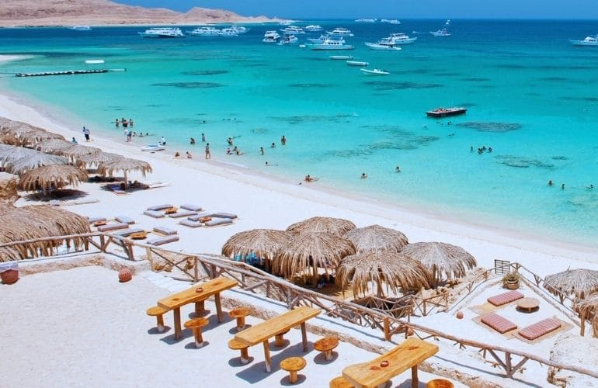

Day 7

Breakfast and Enjoy the sea, sun, and check out from the hotel.

then drive to Cairo airport fly home

**Our program included**

*bottle of water every day included

A guide to speaking the group language is included.

Thanks for visiting EGYPT with our company

ZAMZAM TOURS EGYPT

For more information, please contact us at

Mobile Egypt: +2- 01001791766 HAZEM

Mail : [info@zamzamtoursegypt.com](mailto:info@zamzamtoursegypt.com)

Mobil Spain +34-611725806 MR/Mahmoud

Mobil Spain +34-677308588 MRS/DAVINIA

Mail; [m.ahmed.almenara@gmail.com](mailto:m.ahmed.almenara@gmail.com)

[www.zamzamtoursegypt.com](http://www.zamzamtoursegypt.com)

